# Variance Reduction

### Stratified Sample(SOLUTION_VR_GOODSAMPLE)

*Explanation：*

The main idea is to divide each pixel into four uniform parts and sample one pixel in each part and then we average those pixels value to get our current pixel value.This approach reduces the noise and variance by ensuring that samples are more evenly distributed across the pixel instead of just sample the center.

*Supporting evidence of performance:*

***a)variance reduction***

Because the comparison should be based on the same “sample per pixel”, we use Anti-aliasing which has the same “sample per pixel” to compare the results rendered with the current results.

*Under 5 samples:*

|  |  |
| --- | --- |
| Aniti-Aliasing: | stratified sample |
|  |  |

As We can see, compared to the image rendered by anti-aliasing, the image rendered by stratified sample has already converged much further which means it reduces variance successfully.

*Under 1000 samples:*

|  |  |
| --- | --- |
| Aniti-Aliasing: | stratified sample |
|  |  |

Under 1000 samples, image rendered by stratified sampling is practically the same as image rendered by Anti-Aliasing.

***b)unbiased***

Because this method does not change the rendering equation, it is unbiased as before.

### cos-weighted importance sampling

**(SOLUTION_VR_IMPORTANCES_cos)**

*Explanation：*

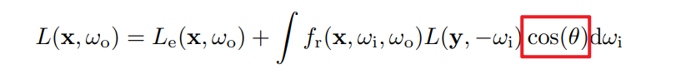

When using Monte Carlo for approximation, in order to reduce the variance, the probability of the sampling direction should be proportional to the integrand(the blue rectangle marked) in path tracing.

In this method we want to do the cos – weighted importance sampling which indicates that the probability is proportional to the cosine term.

So the code corresponding to this method is based on solving the following formula.

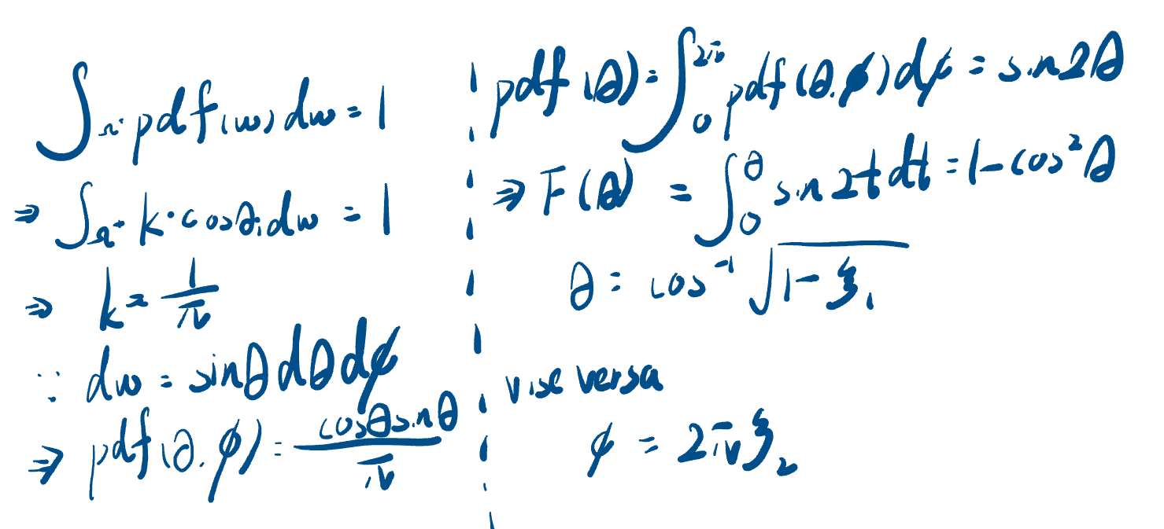

*Supporting evidence of performance:*

***a)variance reduction***

*Under 10 samples:*

|  |  |
| --- | --- |
| no variance reduction(uniform-random sampling): | cos-weighted importance sampling |
|  |  |

For an equal sample count of 10 samples, the image rendered by cos-weighted importance sampling has already converged much further than the image rendered by uniform-random sampling especially in the area circled by green pen.

*Under 1000 samples:*

|  |  |
| --- | --- |
| no variance reduction(uniform-random sampling): | cos-weighted importance sampling |
|  |  |

Under 1000 samples, image rendered by cos-weighted sampling is practically the same as the original image.

***b)unbiased***

We can prove that our algorithm is unbiased by proving the following equation stands:

In our cos-weighted importance sampling we already make and ensure that . And we already learn in the explanation above that , so

### brdf-weighted importance sampling

**(SOLUTION_VR_IMPORTANCES_brdf)**

*Explanation：*

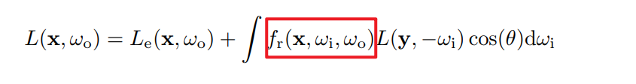

The idea here is very similar to the previous one, but instead of doing importance sampling on the cos term in the formula, we do importance sampling on the formula corresponding to brdf here.

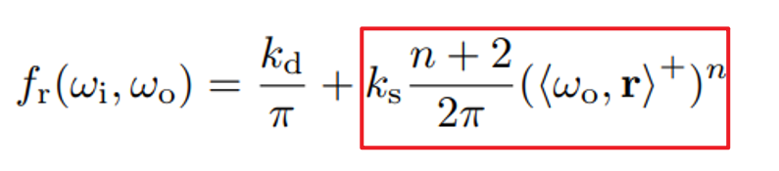

So the code corresponding to this method is based on solving the following formula(we just focus on the specular part).

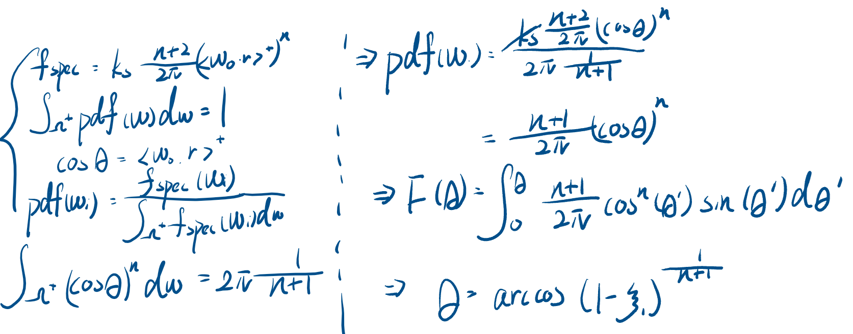

*Supporting evidence of performance:*

***a)variance reduction***

*Under 10 samples:*

|  |  |
| --- | --- |
| no variance reduction(uniform-random sampling): | brdf-weighted importance sampling |
|  |  |

For an equal sample count of 10 samples, the image rendered by brdf-weighted importance sampling has already converged much further than the image rendered by uniform-random sampling especially in the area marked by red rectangle which is the hightlight(specular) part.

*Under 1000 samples:*

|  |  |
| --- | --- |
| no variance reduction(uniform-random sampling): | brdf -weighted importance sampling |
|  |  |

Under 1000 samples, image rendered by brdf-weighted sampling is practically the same as the original image.

***b)unbiased***

We can prove that our algorithm is unbiased by proving the following equation stands:

In our cos-weighted importance sampling we already make and ensure that . So